Brochure on Fetal Alcohol Syndrome
Name
Institution
Date

Brochure on Fetal Alcohol Syndrome
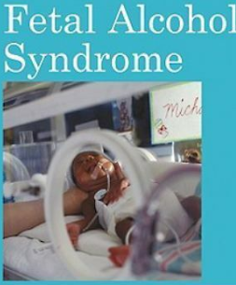
Overall description of the disorder
- Fetal Alcohol Syndrome (FAS) is a condition that occurs as a result of alcohol exposure during pregnancy (Mayo Clinic, 2019).
- In many cases, fetal alcohol syndrome leads to brain damage and growth problems.
- Complications caused by fetal alcohols syndrome vary from child to child. However, its defects are not reversible (Nowak & Michno, 2019).
- There is no recommended amount of alcohol to be consumed during pregnancy.
- Any alcohol consumed during pregnancy places the baby at risk of fetal alcohol syndrome.
- Early diagnosis of alcohol syndrome may help in reducing the risks of fetal alcohol syndrome, such as learning difficulties and behavior issues (Mayo Clinic, 2019).
Evaluation Procedures Fetal Alcohol Disorder
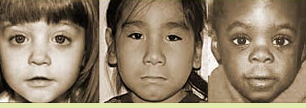
Diagnosis of FAS needs to be done by experts with a thorough assessment.
Early diagnosis boosts the child’s ability to function (Gupta, Gupta, & Shirasaka, 2016).
The evaluation procedures for FAS requires the doctor to:
- Discuss drinking during pregnancy.
- Report the timing and amount of alcohol consumption, your obstetrician, or other health care provider can help determine the risk of fetal alcohol syndrome.
- Watch for signs and symptoms of fetal alcohol syndrome in child’s initial weeks, months, and years of life.
The physician is required to:
- Assess the physical appearances of the baby
- Distinguishing features of the baby
- Monitors the child’s physical and brain growth and development
- Assess cognitive ability and learning and language development difficulties
- Assess health, social, and behavioral issues (Nulman, Shulman, & Liu, 2018).
Distinguishing characteristics and/or behaviors of FAS
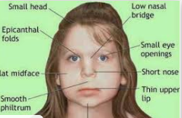

Signs and symptoms of FAS may include physical defects, intellectual disabilities, and social problems

Physical defects
- Distinctive facial features such as the upturned nose, and thin upper lip
- Deformities of joints, fingers, and limbs
- Slow physical growth
- Impaired vision (Mayo Clinic, 2019)
- Small brain size

Cognitive difficulties
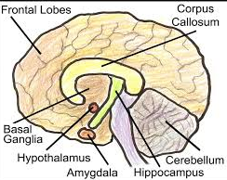
- Poor coordination of balance
- Poor memory (Rangmar et al., 2015)
- Poor judgment skills
- The trouble with attention
- Difficulty in identifying the consequences of choices
- Rapid changing moods
Social and behavioral issues
- Poor social skills.
- Poor concept of time
- Problems with behavior and impulse control
- Trouble in adapting to change from one desk to another
- Difficulty in school (Mayo Clinic, 2019)
- Problems in staying on task

Possible causes of FAS
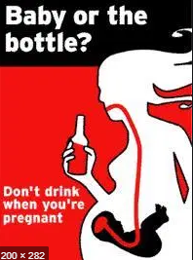
- Exposure to alcohol before birth which causes permanent brain damage to the baby.
- Alcohol enters the mother’s bloodstream and reaches the developing baby by crossing the placenta.
- Alcohol leads to higher blood alcohol concentration in the developing baby.
- Alcohol reduces the delivery of oxygen in addition to optimal nutrition to the developing baby.

Age of onset of FAS
- FAS starts between 0 to 9 months of pregnancy when one takes alcohol
- Its features can be defined after birth
- Some features are defined between 8 months and 8 years

Recommended best practices for instruction and placement
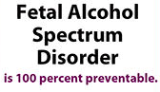
FAS can be prevented through the following guidelines:
- Avoid alcohol when you are trying to get pregnant
- Avoid alcohol all through pregnancy (Mayo Clinic, 2019).
- Consider avoiding alcohol during childbearing years
- In case you have an alcohol problem, get assistance before you get pregnant for a treatment plan.

References
Gupta, K. K., Gupta, V. K., & Shirasaka, T. (2016). An update on fetal alcohol syndrome—pathogenesis, risks, and treatment. Alcoholism: Clinical and Experimental Research, 40(8), 1594-1602.
Mayo Clinic, (2019). Fetal alcohol syndrome. Retrieved from https://www.mayoclinic.org/diseases-conditions/fetal-alcohol-syndrome/symptoms-causes/syc-20352901
Nowak, A., & Michno, A. (2019). FASD–Fetal Alcohol Syndrome Disorder. World Scientific News, 129, 242-254.
Nulman, I., Shulman, T., & Liu, F. (2018). Fetal alcohol spectrum disorder. In Handbook of Developmental Neurotoxicology (pp. 427-437). Academic Press.
Rangmar, J., Hjern, A., Vinnerljung, B., Strömland, K., Aronson, M., &Fahlke, C. (2015). Psychosocial outcomes of fetal alcohol syndrome in adulthood. Pediatrics, 135(1), e52-e58.

